Suchithra K & Lata S

Download and Install Tableau

An instructional guide

**Contents**

1. Download 14 days Free trial 1

2. Download Tableau for Students 5

3. Study Materials…………………………………………………………………………………………………………………….7

.

# **Guidelines**

Students or learners can download either **14 days Free trial** or **Tableau for Students**. We suggest you to download Free trial a week before the training session to begin with the learning and hands on. Tableau for Students lasts for a year, which can be used for advanced learning or developing a project after you get more familiar with Tableau.

# **Download 14 days Free trial**

## Step 1.1 : Search for Tableau desktop free trial in a preferred browser. Click on the first link.

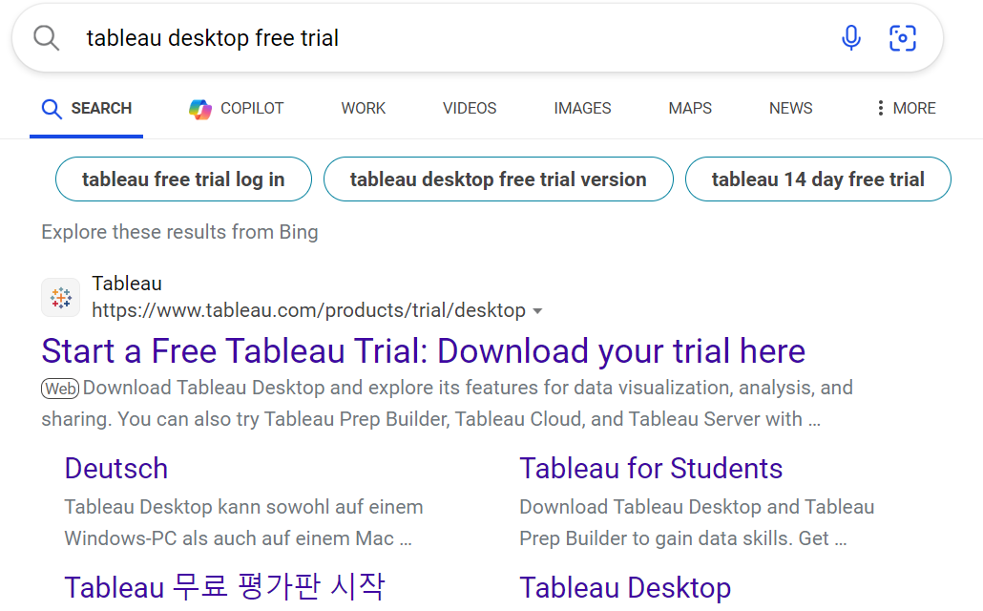

## Step 1.2 : Click on “Download Free Trial”.

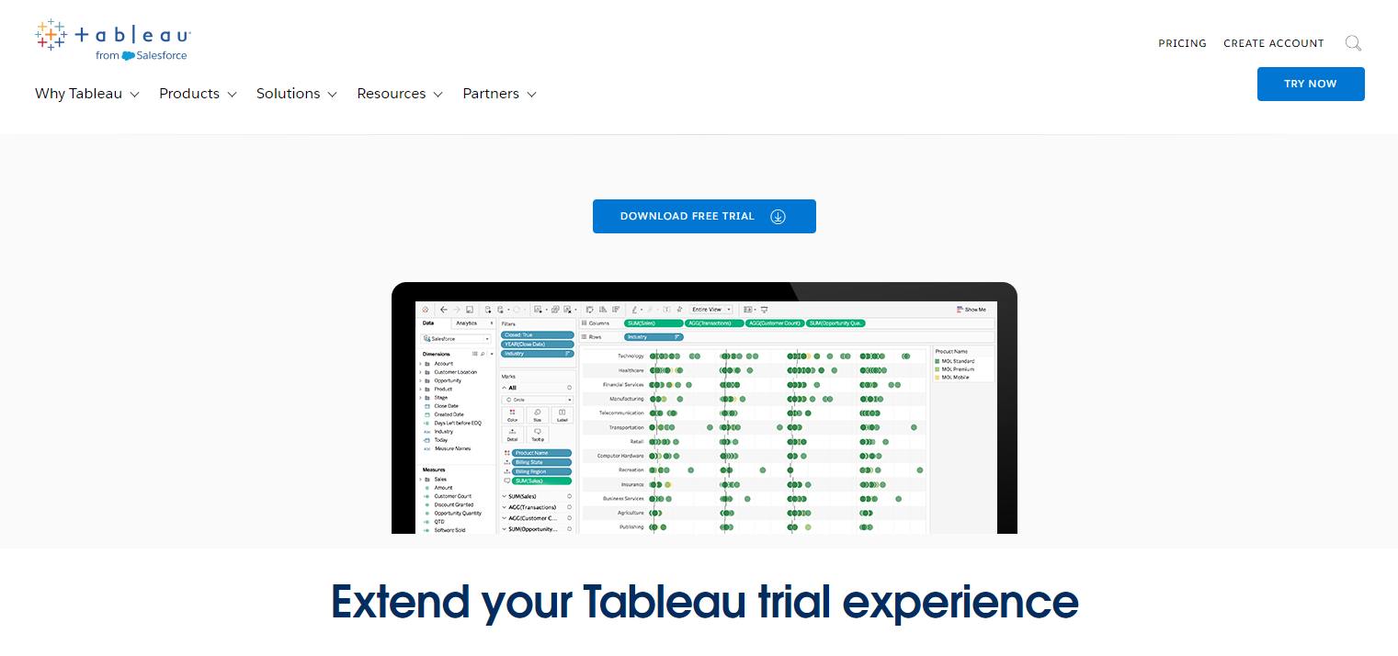

## Step 1.3 : Fill in your details. Please fill your personal / college Mail ID in “Business E-mail” and College Name in “Organization” sections and click on Submit.

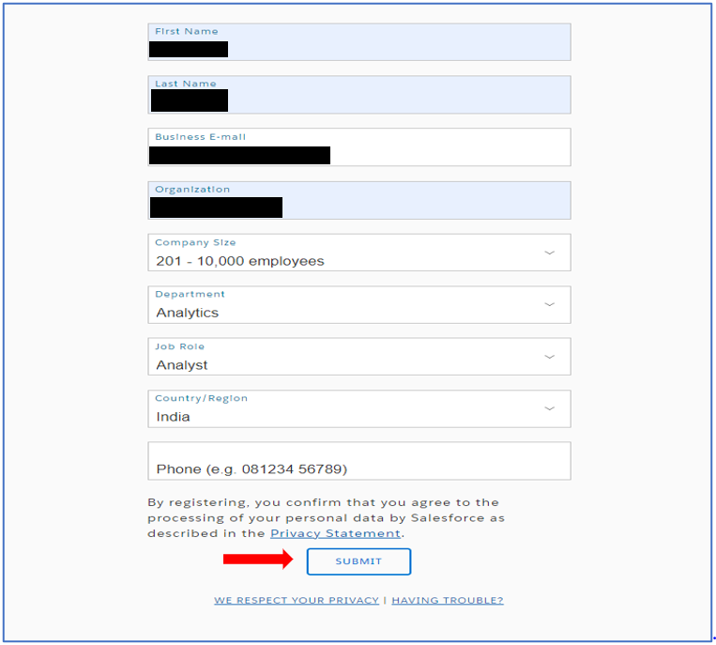

## Step 1.4 : Once submitted, **Tableau 2024.1** version file starts downloading automatically, else click the link as shown below.

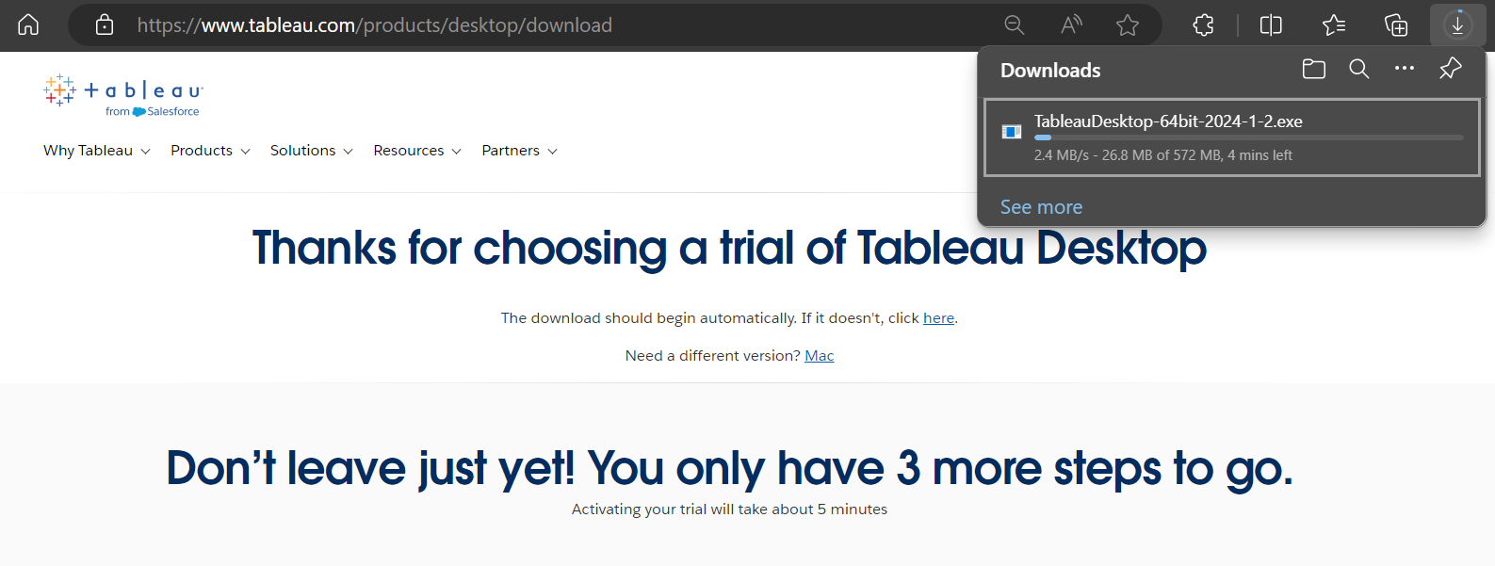

## Step 1.5 : Look for the Application in Download folder of your PC and double click it.

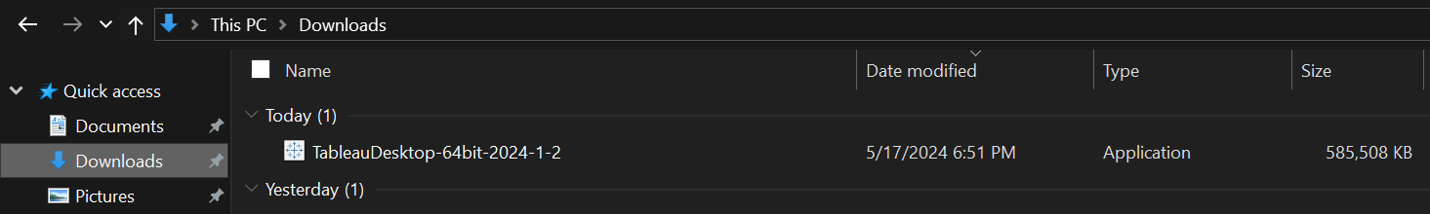

## Step 1.6 : Check the mentioned boxes and click on Install.

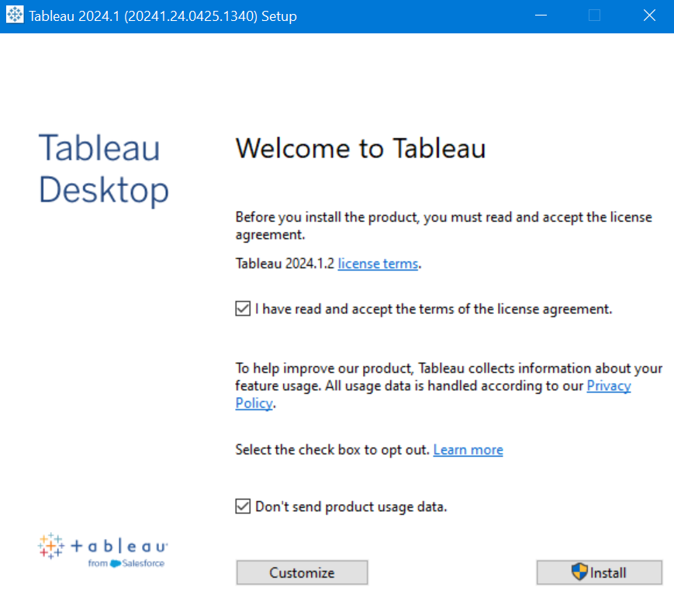

## Step 1.7 : Activate Tableau by providing the details.

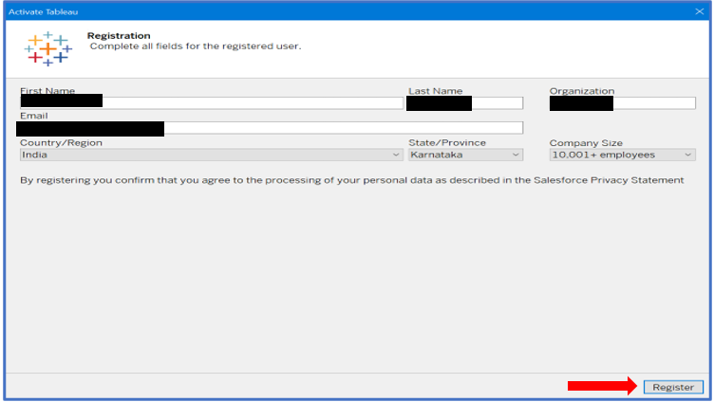

## Step 1.8 : Once registration is complete, Tableau is ready to use.

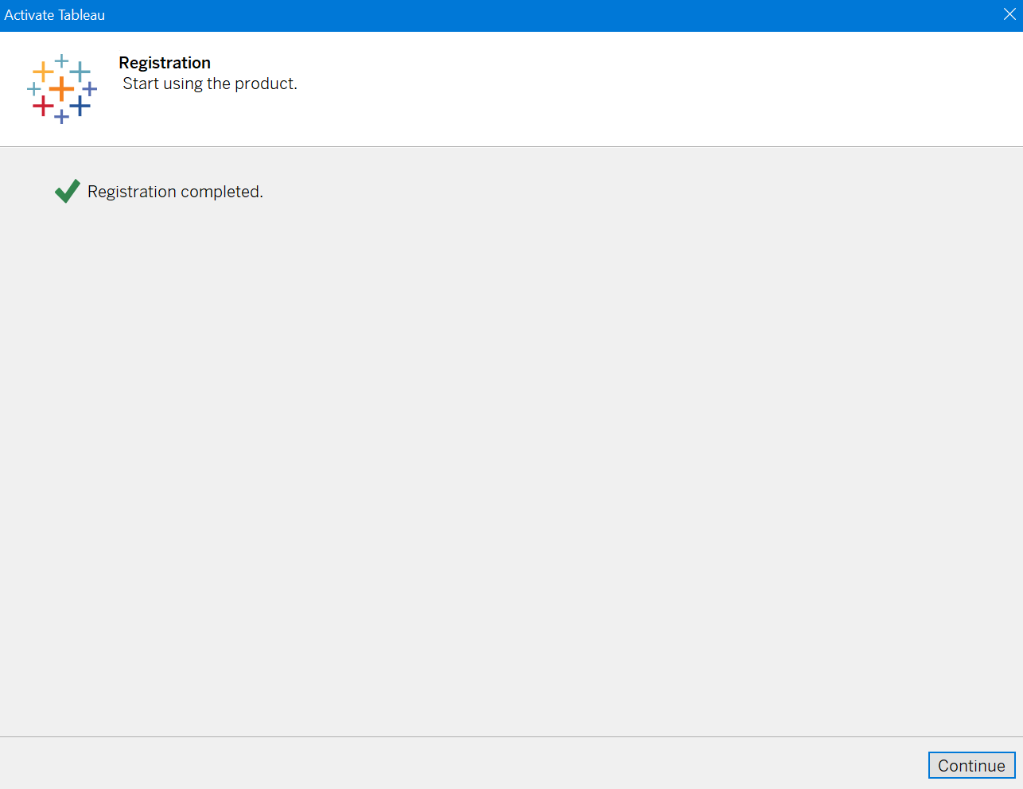

## Step 1.9 : Look for Tableau in Start Menu.

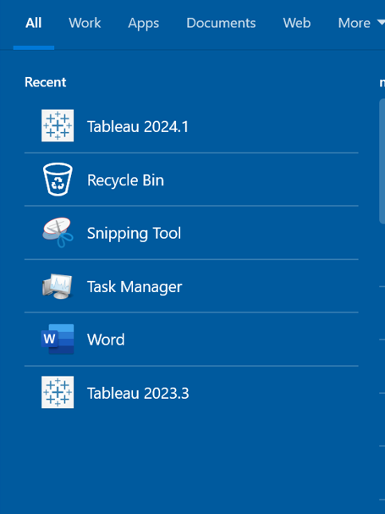

# **Download Tableau for Students**

## Step 2.1 : Search for Tableau desktop for Students in a preferred browser. Click on the first link.

Tableau provides **1 year** free license for students.

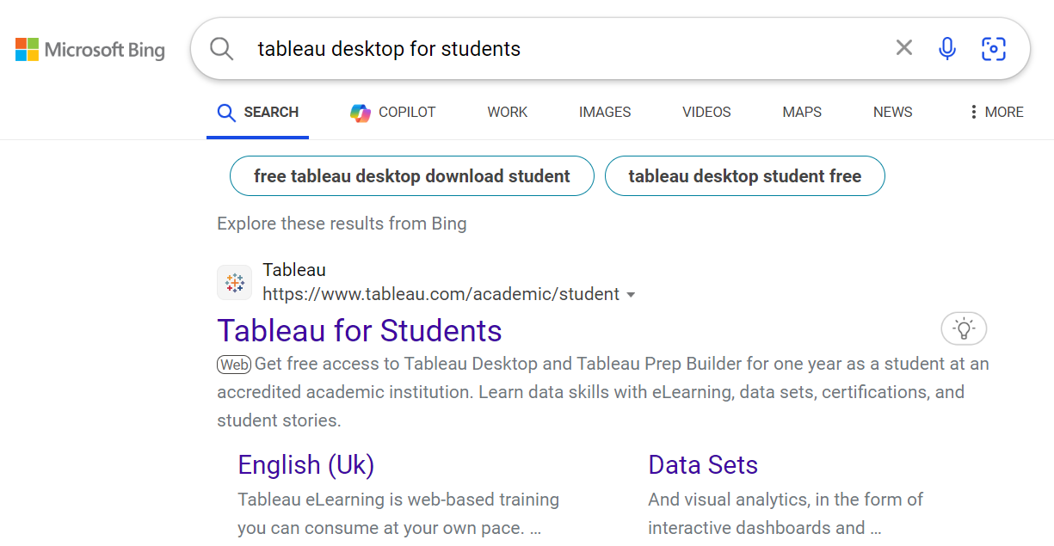

## Step 2.2 : Click on “Get Tableau for free”.

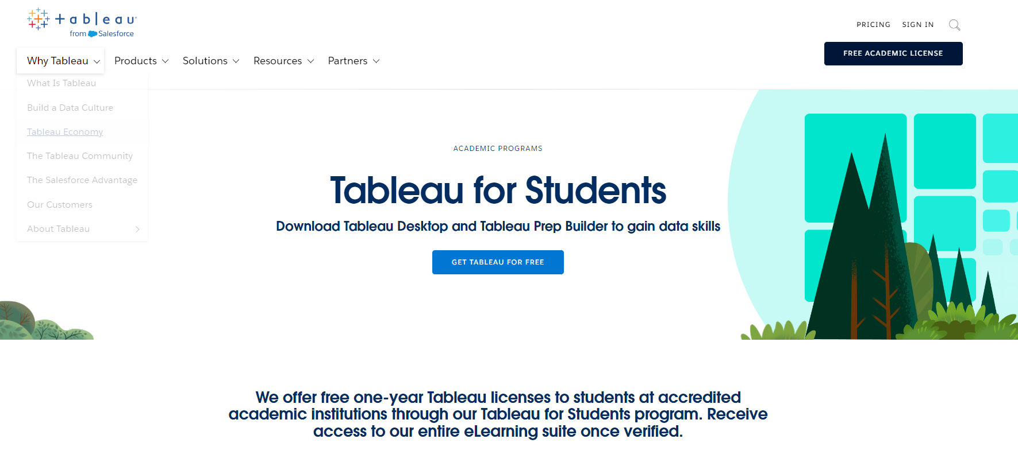

## Step 2.3 : Fill in your details and click on “Verify Student Status”. Make sure to provide valid college Mail ID. You will receive an **Activation code** which is needed for Activation.

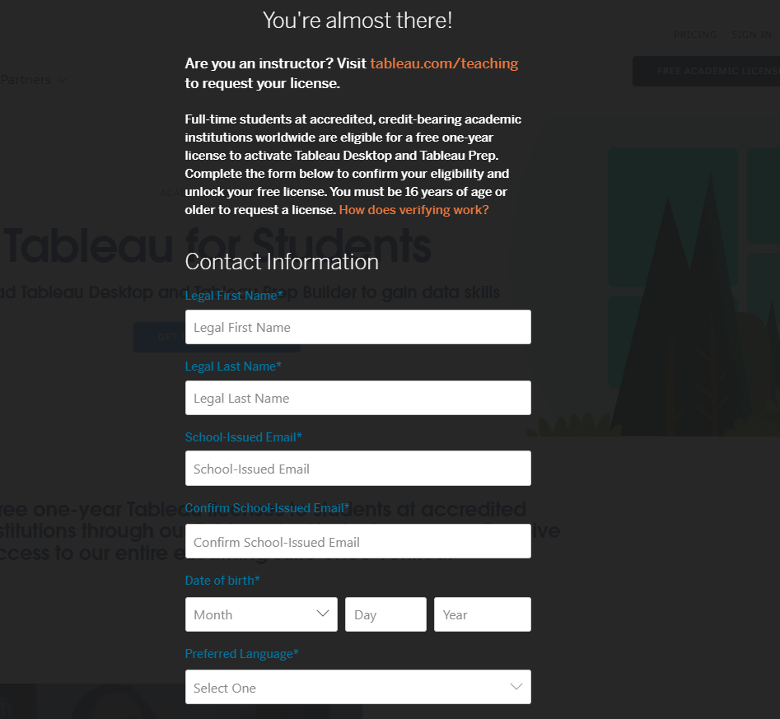

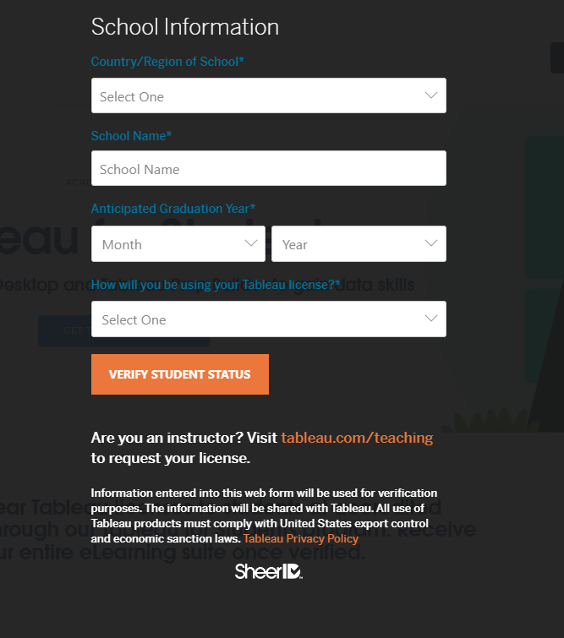

## Step 2.4 : Follow Step 1.4 to 1.6. To activate the license, click on “Activate with product key” option.

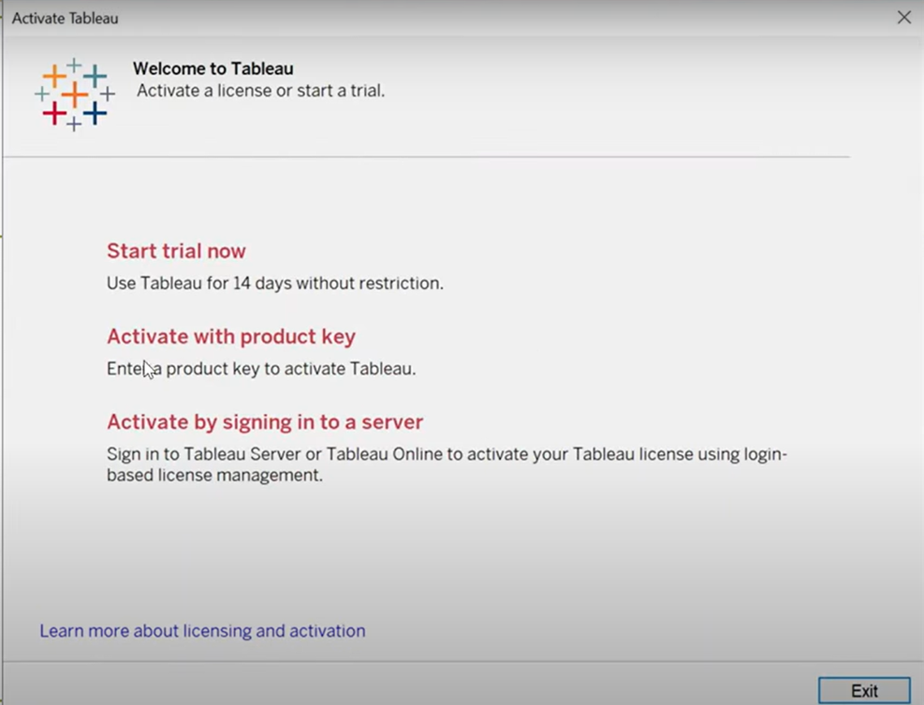

## Step 2.5 : Enter the Activation code received in the registered college Mail ID. Once activated, Tableau is ready to use.

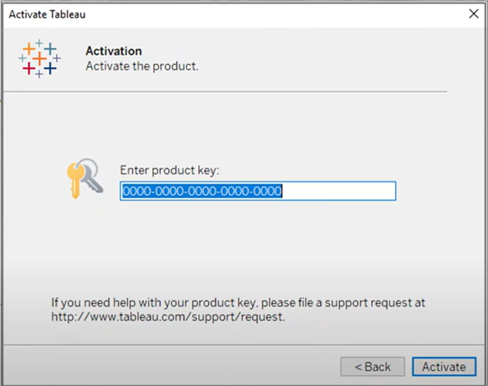

# **Study Materials**

* [Learning Videos](https://www.bing.com/videos/riverview/relatedvideo?&q=tableau+charts&&mid=E651C46D2E5914A51D53E651C46D2E5914A51D53&&FORM=VRDGAR)
* [Training Path](https://www.tableau.com/learn/training)